Distillation

Aim: Carry out practical work to separate a pure sample of water from some inky water.
Safety: Goggles must be worn. Be careful using hot glassware.

What is distillation?

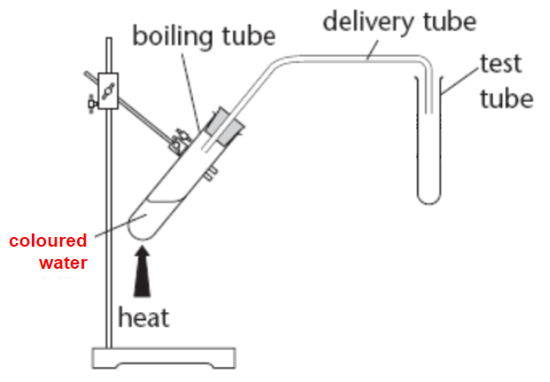 | What is the main issue with this apparatus?
Draw a labelled diagram of some better apparatus including a Liebig condenser.

Analysis/conclusion:

1) Explain (in terms of the particles involved) how you were able to separate a pure sample water from your mixture.

2) How could a student test the purity of the water they obtained from this experiment?

3) You can buy ‘distilled’ water from many shops. What does this tell us about the purity of the water that we are buying?

4) Why do we buy ‘mineral’ water instead of ‘distilled’ water? What are the advantages of each?

5) How is fractional distillation is different from simple distillation.

6) A mixture of three liquids needs separating. The expected temperature range for collecting each liquid in the distillate is shown below.
liquid X: 40°C-100°C liquid Y: 120°C-160°C liquid Z: 180°C -200°C
The mixture was added to the distillation apparatus and was heated quickly to 150°C. Select the row of the table that shows what would be collected in the distillate.
